STUDENT ENROLLMENT & COURSE MANAGEMENT SYSTEM (SECMS)
User Story
The Student Enrollment & Course Management System is a comprehensive Salesforce application designed to streamline and automate the academic enrollment operations of an educational institute. This system enables administrators, enrollment officers, and instructors to efficiently manage student records, course offerings, enrollments, instructor assignments, approval processes, payments, and reporting—all within a unified Salesforce environment.
1. INTRODUCTION
1.1 Project Overview
The Student Enrollment & Course Management System (SECMS) is a Salesforce-based application developed to manage student information, courses, instructors, and student enrollment activities in an organized manner. The system provides a centralized platform for storing and managing student and course-related information.
The system allows administrators to create student records, maintain course details, manage instructors, and enroll students into available courses. Salesforce objects, fields, relationships, validation rules, flows, reports, dashboards, and security features are used to develop the application.
1.2 Purpose
The main purpose of SECMS is to simplify and automate the student enrollment and course management process. It reduces manual data entry, improves data accuracy, and provides easy access to student and course information.
1.3 Objectives
The main objectives are:
- To maintain student information in a centralized system.
- To manage available courses and instructors.
- To simplify student enrollment.
- To establish relationships between students, courses, and enrollments.
- To validate student and course information.
- To automate enrollment-related activities.
- To generate useful reports and dashboards.
2. IDEATION PHASE
2.1 Problem Statement
Educational institutions often manage student enrollment, course details, and instructor information using manual records or separate systems. This can result in duplicate data, difficulty in tracking enrollments, delayed updates, and difficulties in generating reports.Therefore, a centralized Student Enrollment & Course Management System is required to manage student, course, instructor, and enrollment information efficiently.
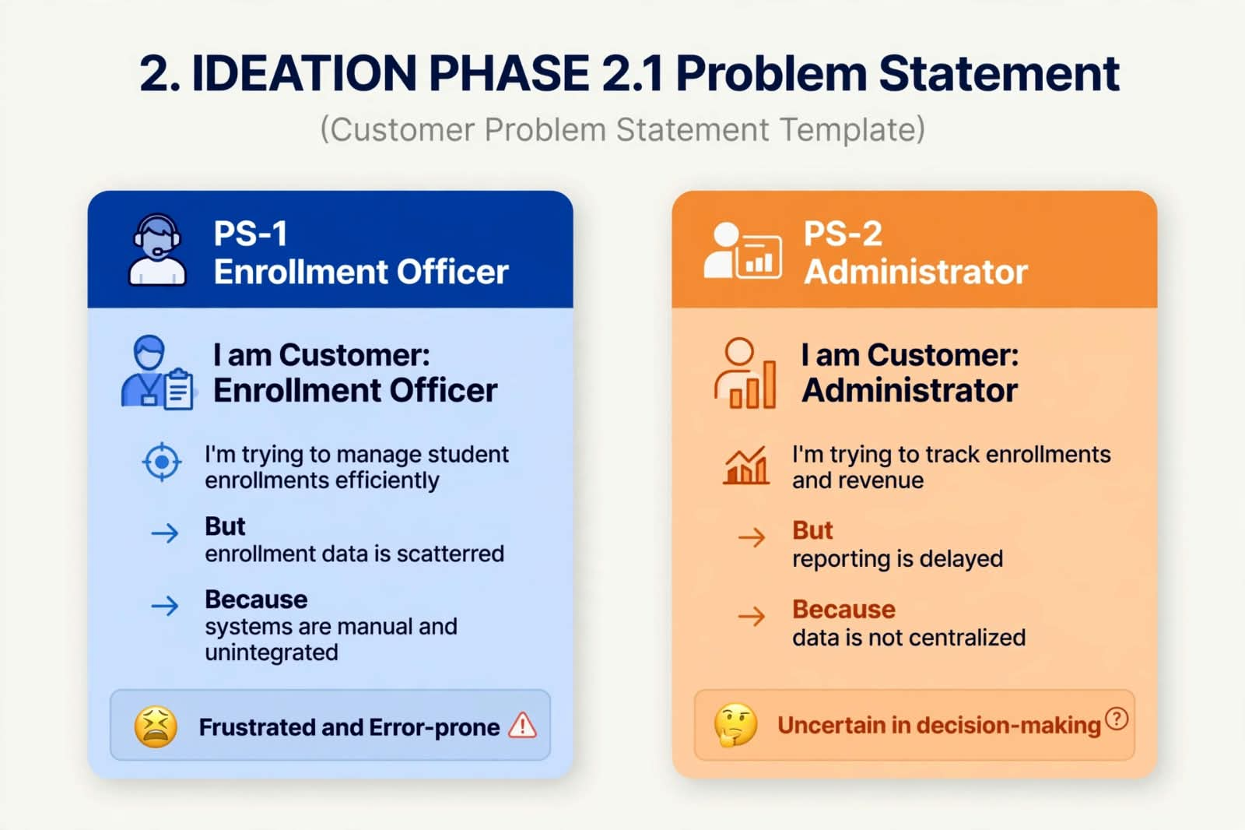

2.2 Empathy Map

Students
- Think: Which courses are available?
- Feel: Need an easy enrollment process.
- Say: I want to know my enrollment status.
- Do: Select courses and provide personal details.

Administrator
- Think: How can student records be managed easily?
- Feel: Need accurate and organized data.
- Say: Enrollment information should be available quickly.
- Do: Manage students, courses and enrollments.

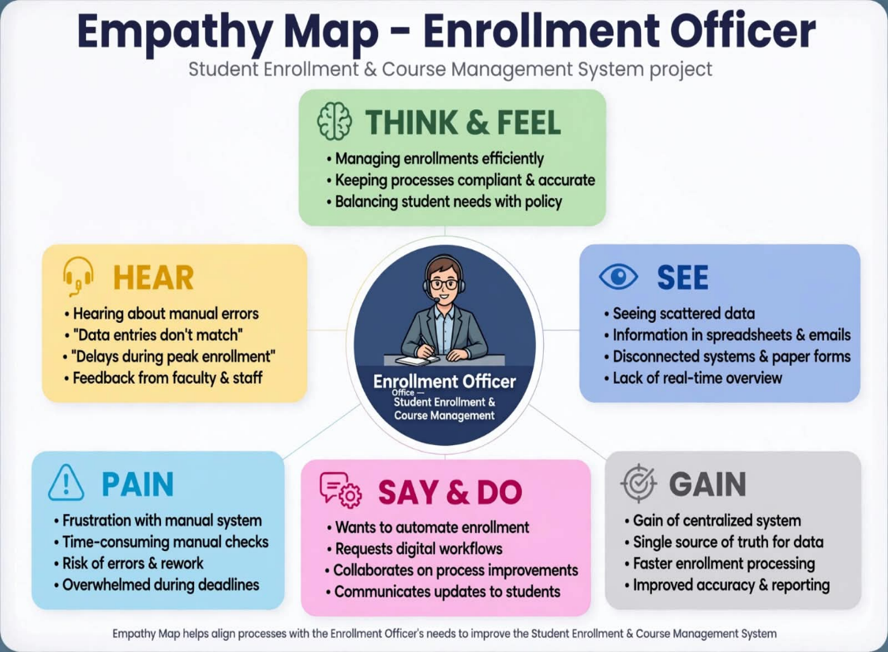
Step 1 - Brainstormed Ideas:
- Spreadsheet automation
- Standalone enrollment portal
- ERP integration
- Salesforce-based enrollment system
Step 2 - Grouping:
- Manual solutions
- Semi-automated solutions
- Fully automated cloud solutions
3. REQUIREMENT ANALYSIS PHASE
3.1 Customer Journey Map
Stages Covered:
- Awareness & Registration
- Course Selection
- Enrollment Request
- Fee Payment
- Approval
- Instructor Assignment

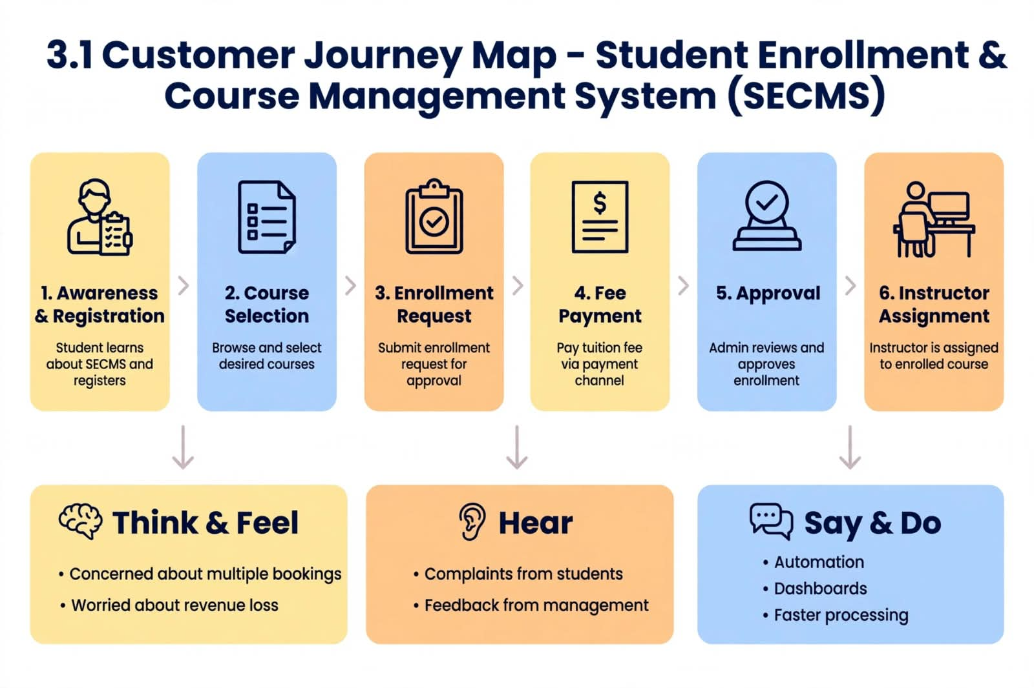
3.2 Functional Requirements
The system should provide:
- Student record creation.
- Course record creation.
- Instructor record management.
- Enrollment record creation.
- Student-course relationship.
- Validation rules.
- Automated workflows.
- Approval process.
- Reports.
- Dashboards.
- User security.
3.3 Non-Functional Requirements
- Security: Only authorized users should access the system.
- Reliability: Data should be stored accurately.
- Usability: The application should be easy to use.
- Performance: Records and reports should load efficiently.
- Scalability: The system should support additional students and courses.

4. PROJECT DESIGN PHASE
4.1 Problem-Solution Fit

Problem-Solution Fit is the process of aligning identified customer pain points with a viable, feasible, and desirable solution that solves them effectively.

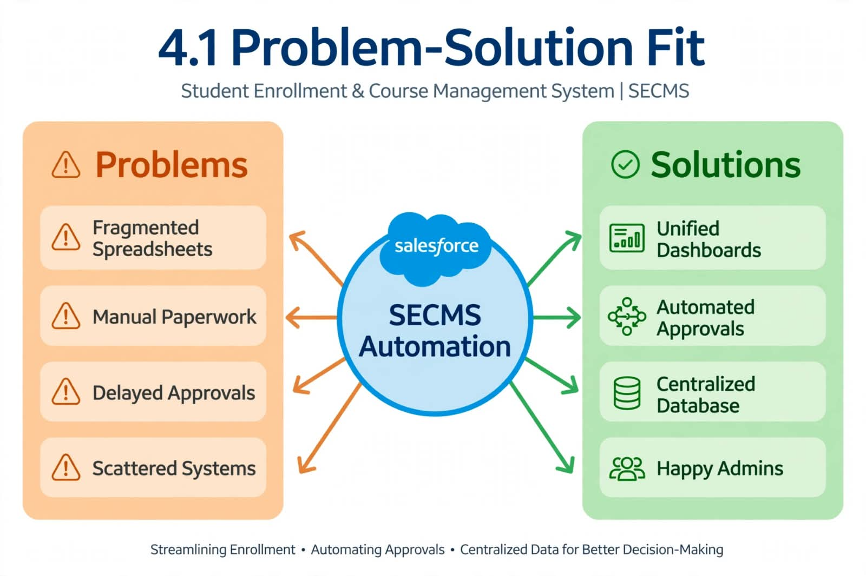
4.2 PROPOSED SOLUTION
FunctionalRequirements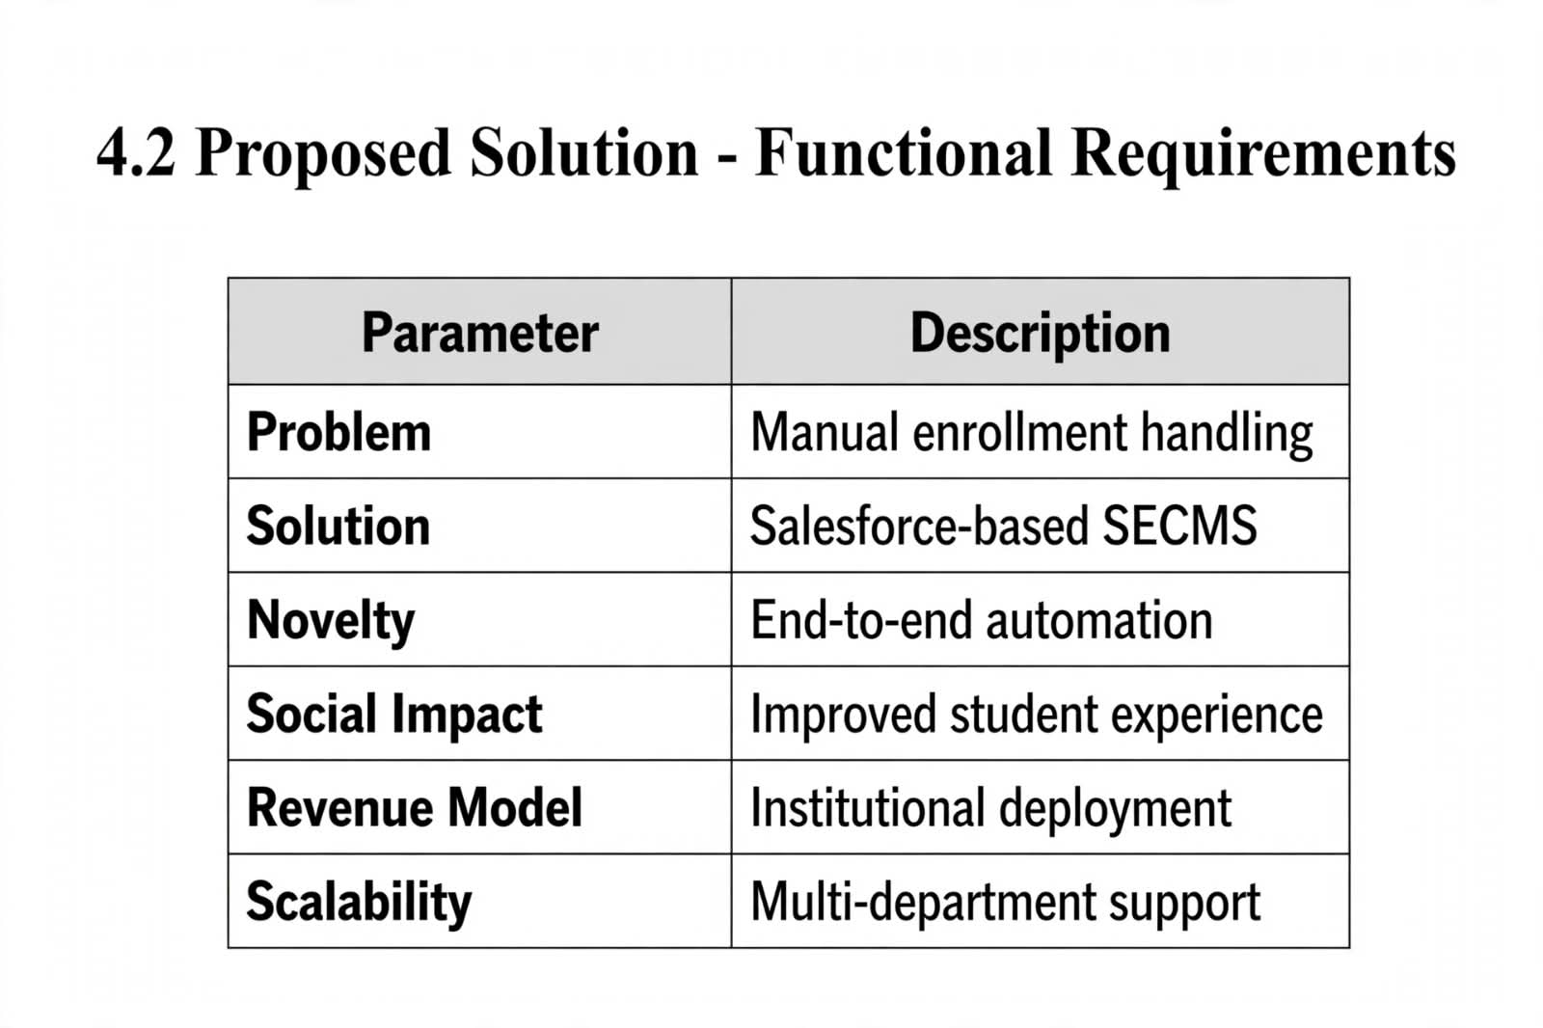
4.3 SOLUTION ARCHITECTURE
The Student Enrollment & Course Management System (SECMS) is designed on a Layered Architecture Model built entirely on the Salesforce Platform.
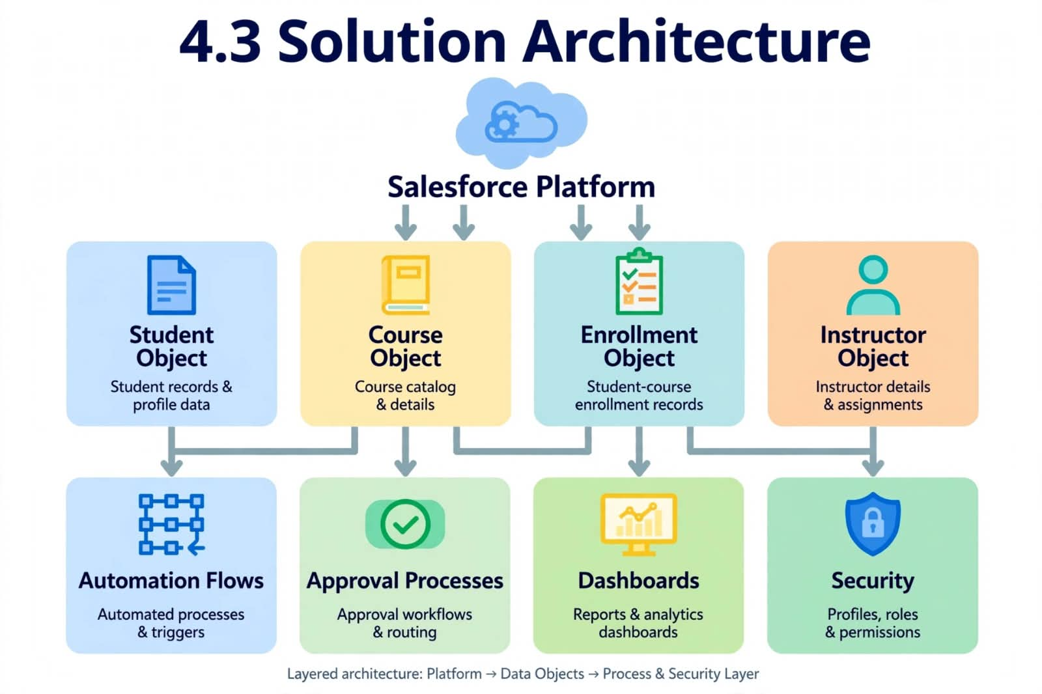
5. PROJECT PLANNING AND SCHEDULING
5.1 Project planning
Project Planning is the process of defining methodology, breaking epics into user stories, assigning story points, and scheduling work into sprints for systematic execution.
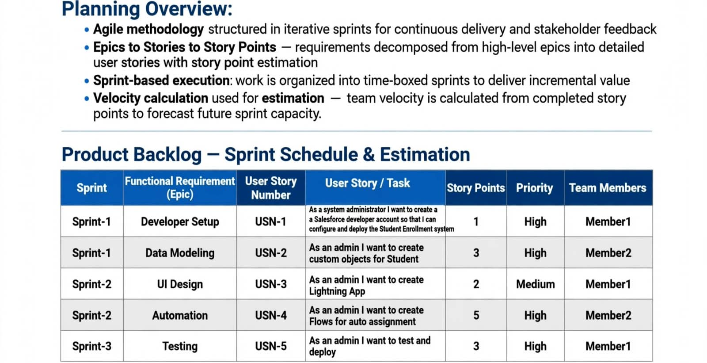

  - Project Development Phase
Project Flow:
Milestone 1: Salesforce Developer Account Creation
Milestone 2: Custom Object Creation (Student, Course, Enrolment, Instructor)
Milestone 3: Tabs Creation
Milestone 4: Lightning App Creation
Milestone 5: Fields Creation
Milestone 6: Create Relationships
Milestone 7: Page Layout Customization
Milestone 8: Validation Rules
Milestone 9: Flows (Automation)
Milestone 10: Approval Process
Milestone 11: Reports
Milestone 12: Dashboards
Milestone 13: Security Setup
Milestone 14: Conclusion
Milestone 1: Salesforce Developer Account Creation
Salesforce Developer Org is a free, permanent Salesforce environment provided by Salesforce to developers and students to learn, build, and test applications.In this org, we have full access to Salesforce features like Custom Objects, Tabs, Lightning App, Flows, Reports, and Dashboards. Our entire Student Enrollment & Course Management System (SECMS) project is built inside this Developer Org.
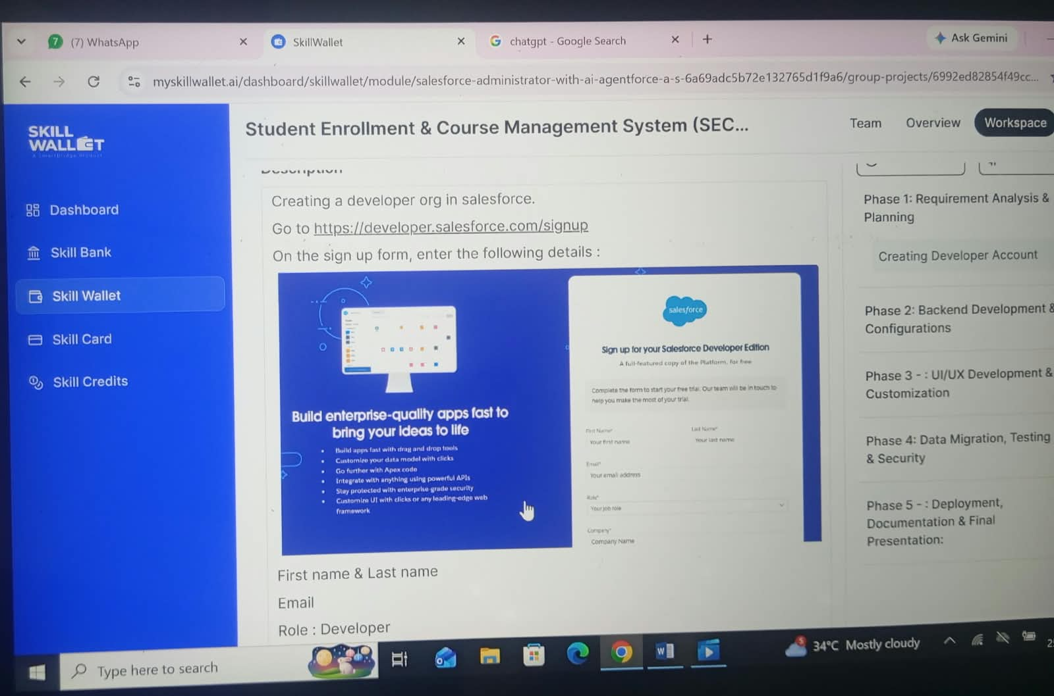
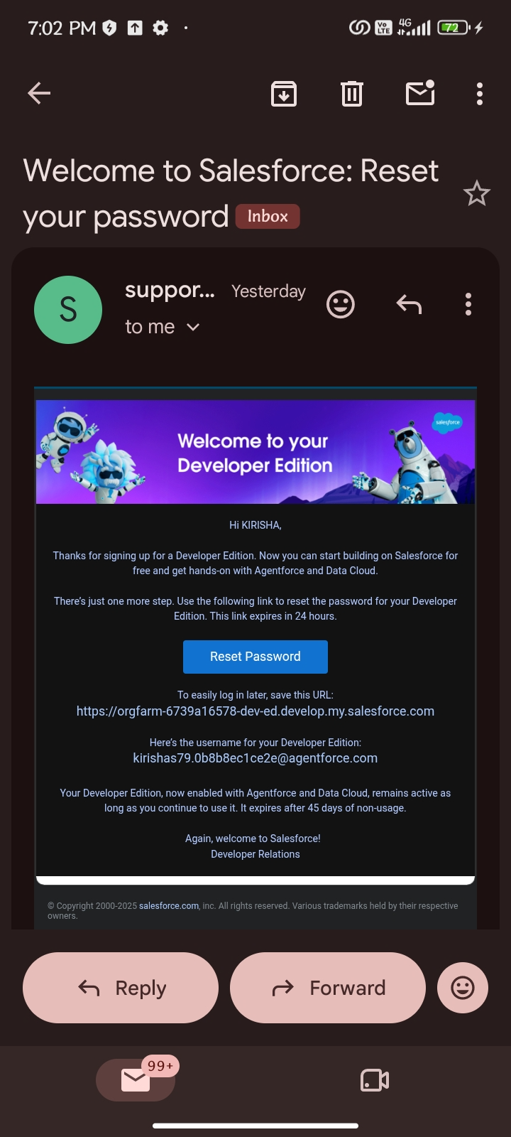
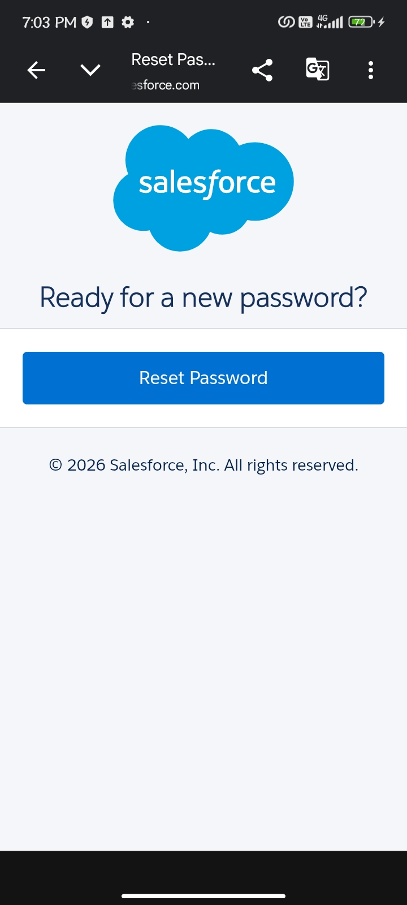

Milestone 2 – Object:Activity 1: Creating Student Object:
The purpose of creating the Student custom object is to store and manage information about students such as their personal details, contact information, and enrolment status.
To create the Student object:
Go to the Setup page.
Click on Object Manager.
Click on Create → Custom Object.
Enter the details as below:
Label: Student
Plural Label: Students
Object Name: Student
Record Name: Student Name
Data Type: Text
Check Allow Reports, Allow Activities, Track Field History
Click Save
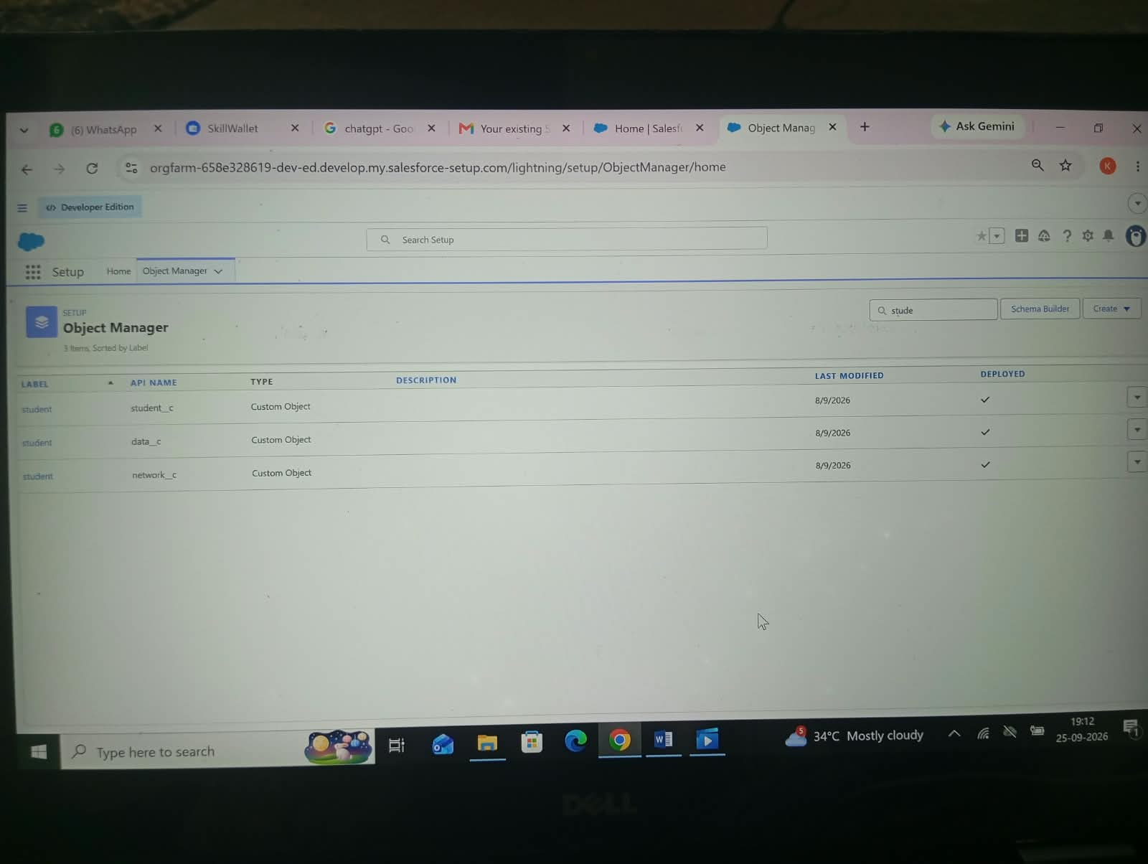
Activity 2: Creating Course Object:
The purpose of creating the Course custom object is to store and manage information about courses offered, such as course name, duration, fees, and description.
To create the Course object:
Go to Setup → Object Manager → Create → Custom Object
Label: Course
Plural Label: Courses
Record Name: Course Name
Save
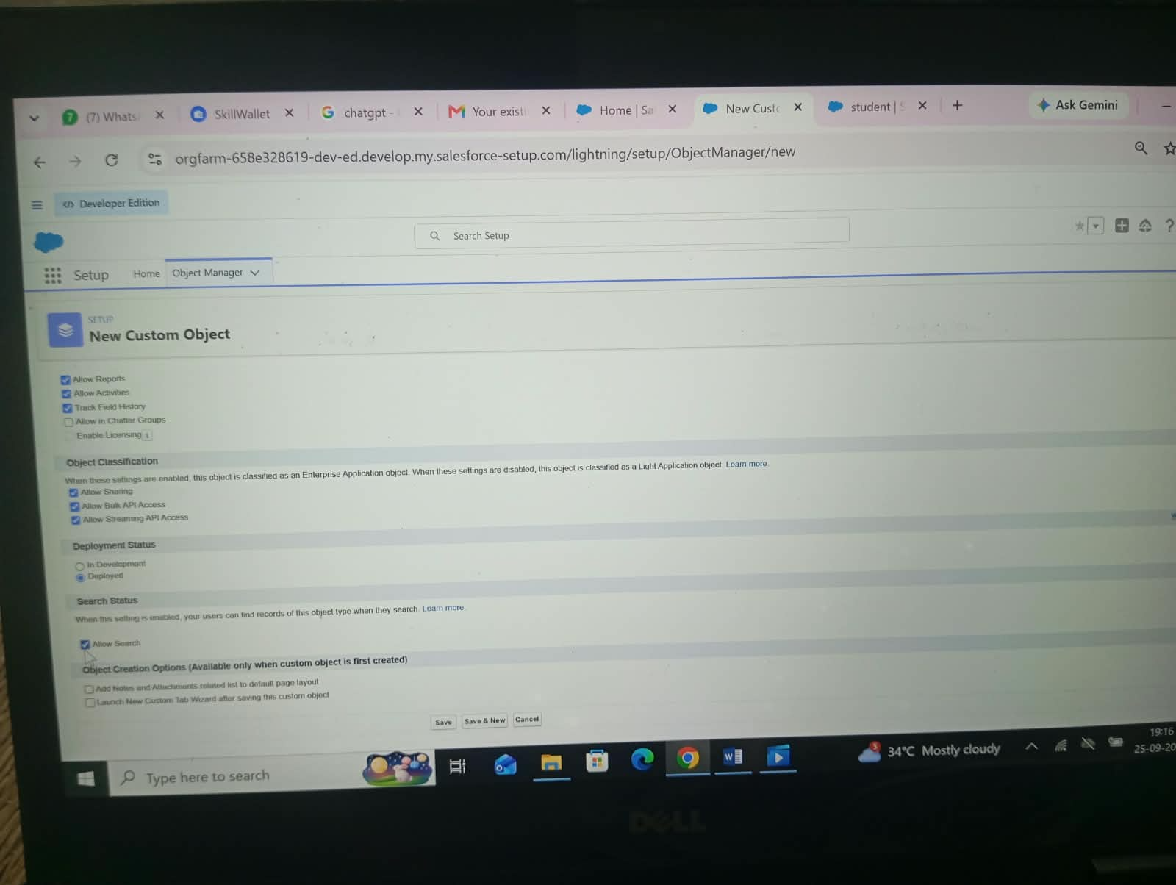
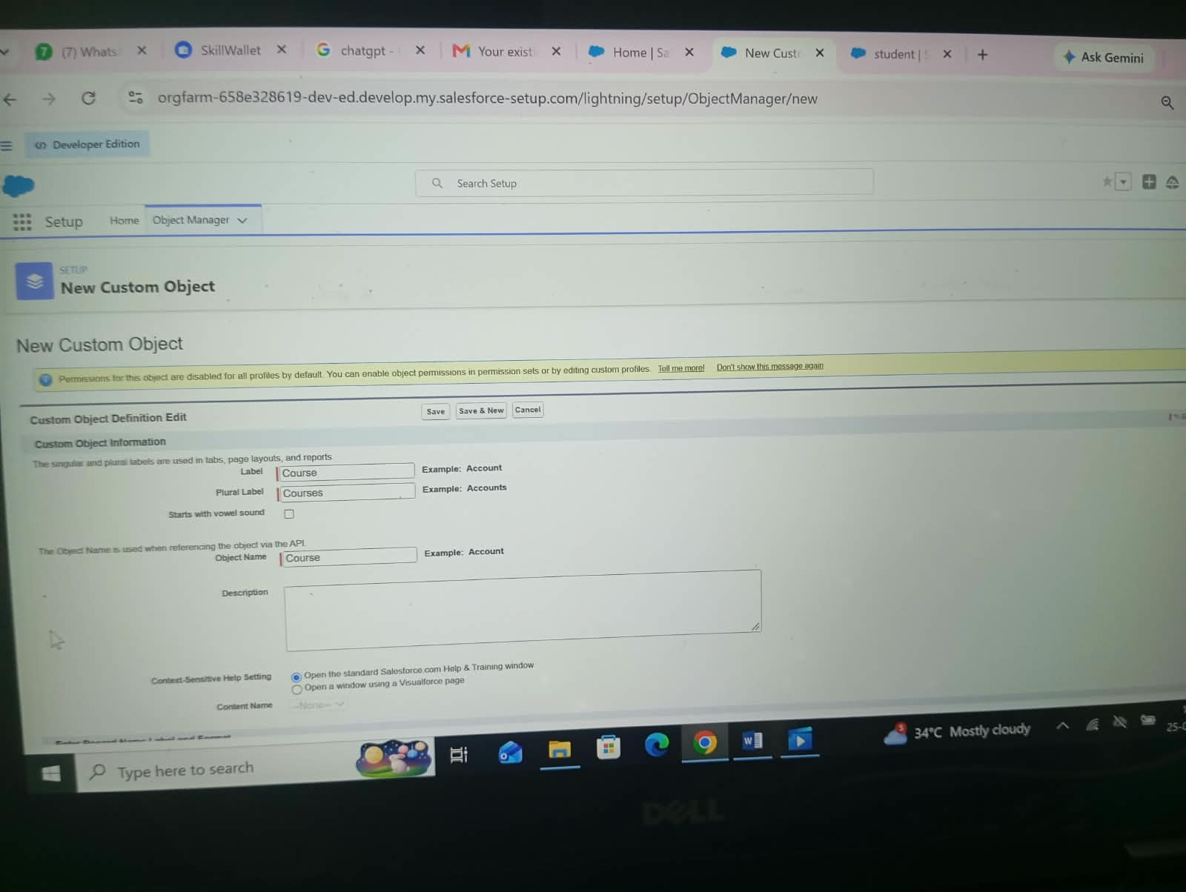

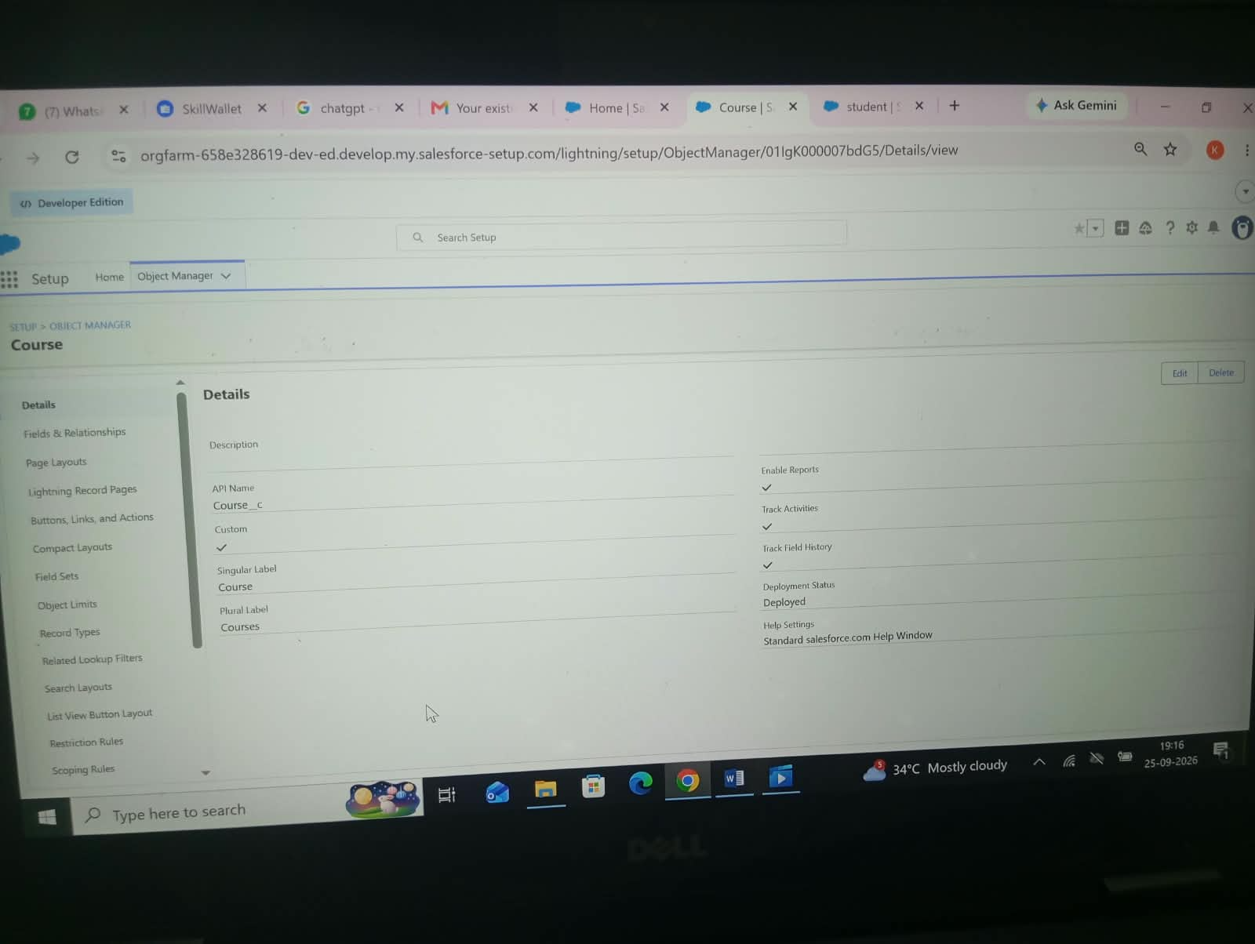
Activity 3: Creating Instructor Object:
The purpose of creating the Instructor custom object is to store and manage information about instructors such as their name, expertise, and contact details.
Label: Instructor
Plural Label: Instructors
Record Name: Instructor Name
Save
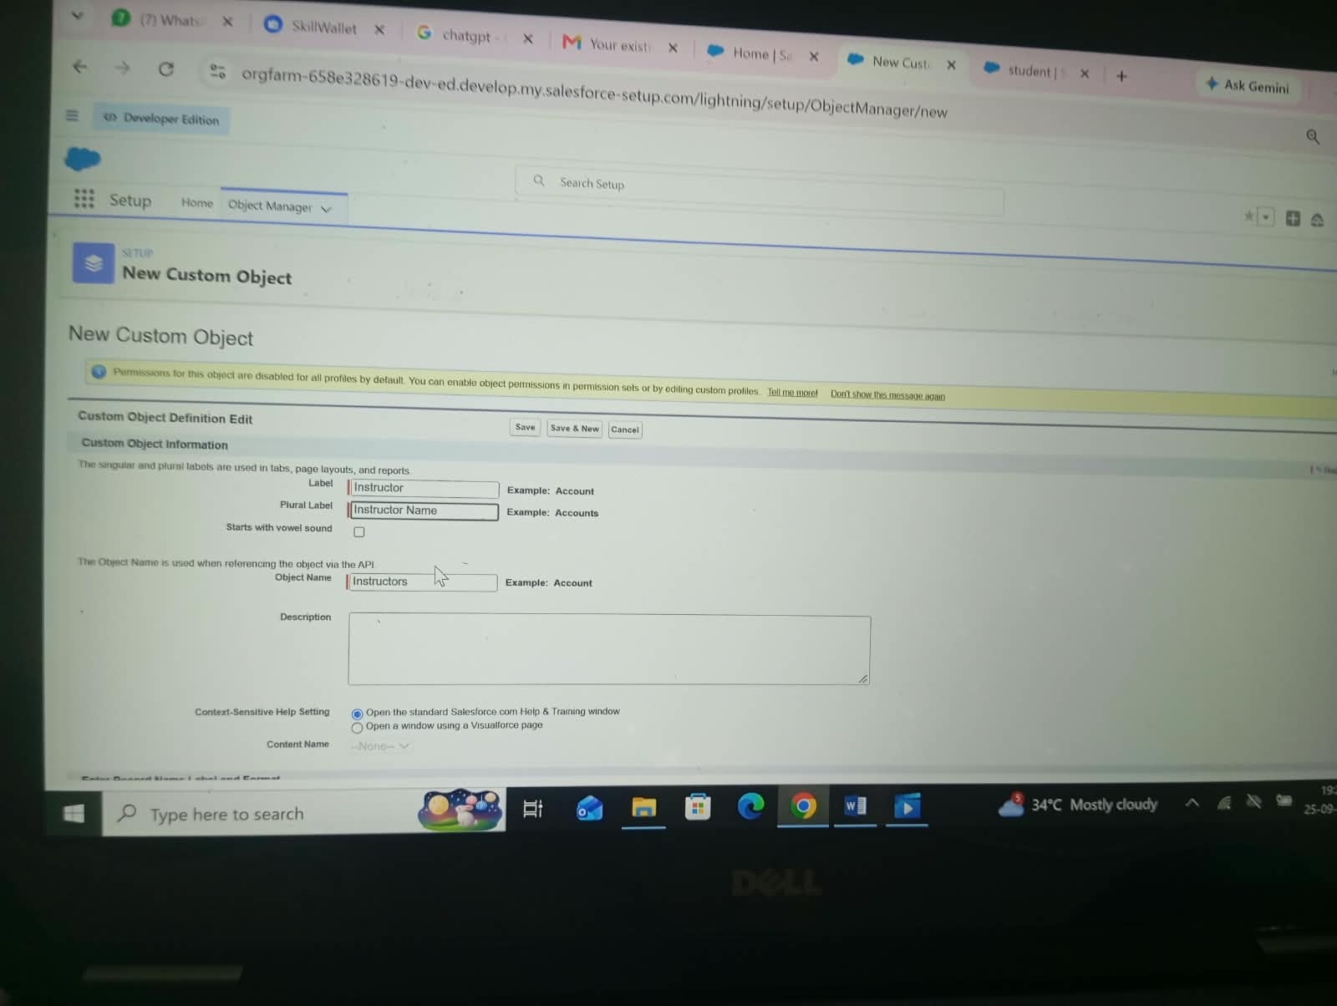

Activity 4: Creating Enrollment Object:
The purpose of creating the Enrollment custom object is to track which student is enrolled in which course. It acts as a junction object between Student and Course.
Label: Enrollment
Plural Label: Enrollments
Record Name: Enrollment Number
Data Type: Auto Number - Format: EN-{0000}
Save
3: Tabs Creation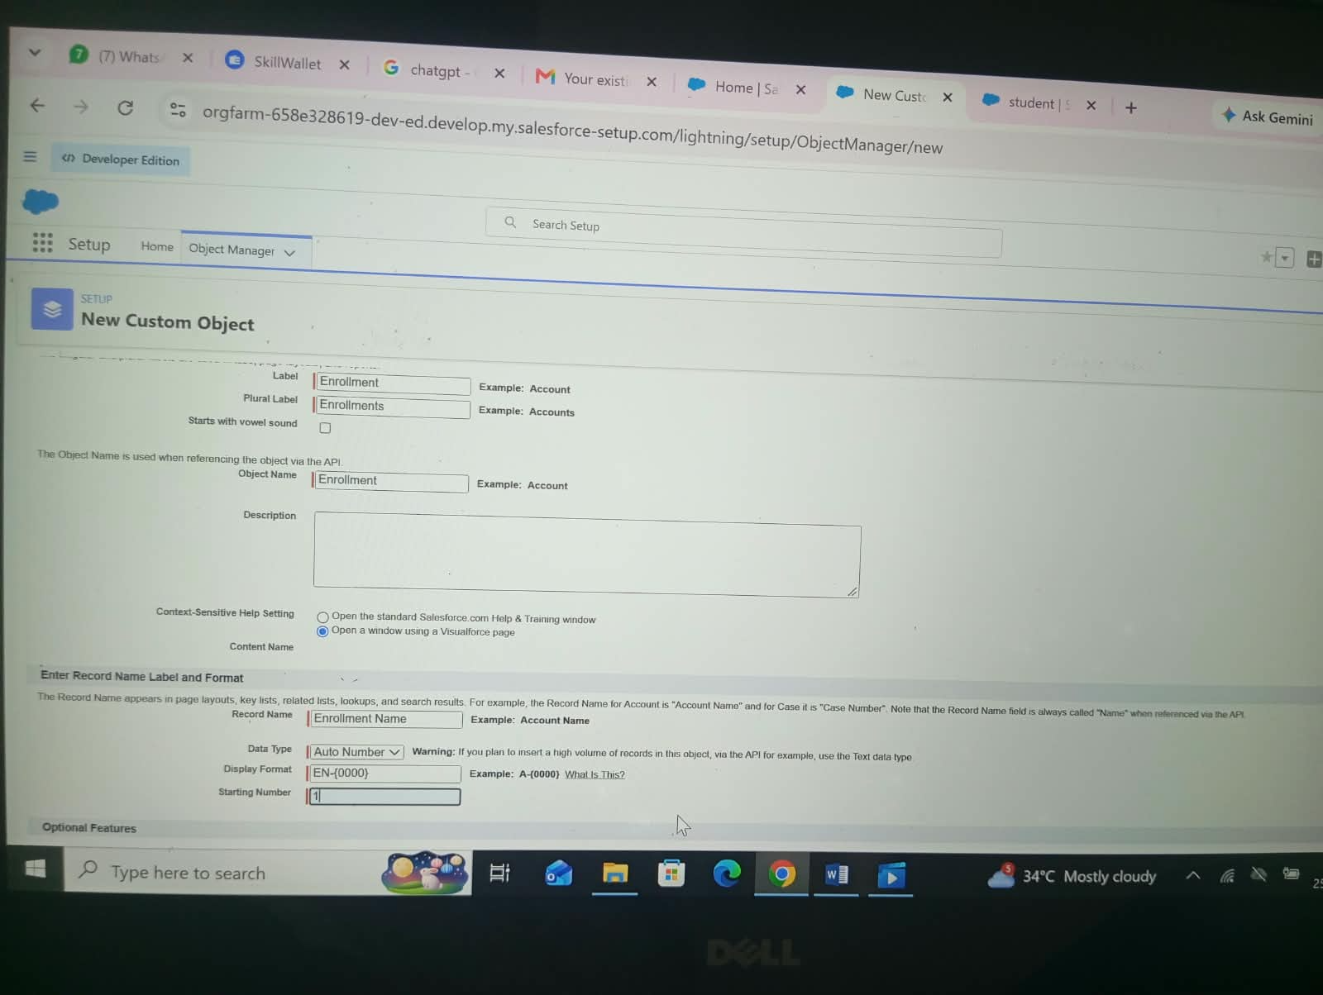
Milestone 3: Tabs Creation
Activity 1: Creating Student Tab:
The purpose of creating the Student Tab is to provide a user interface to access the Student object records easily from the navigation bar.
To create the Student Tab:
Go to Setup page.
Type Tabs in Quick Find → Click on Tabs.
Under Custom Object Tabs, click New.
Select Object: Student
Select Tab Style: Choose any icon
Click Next → Next → Save.
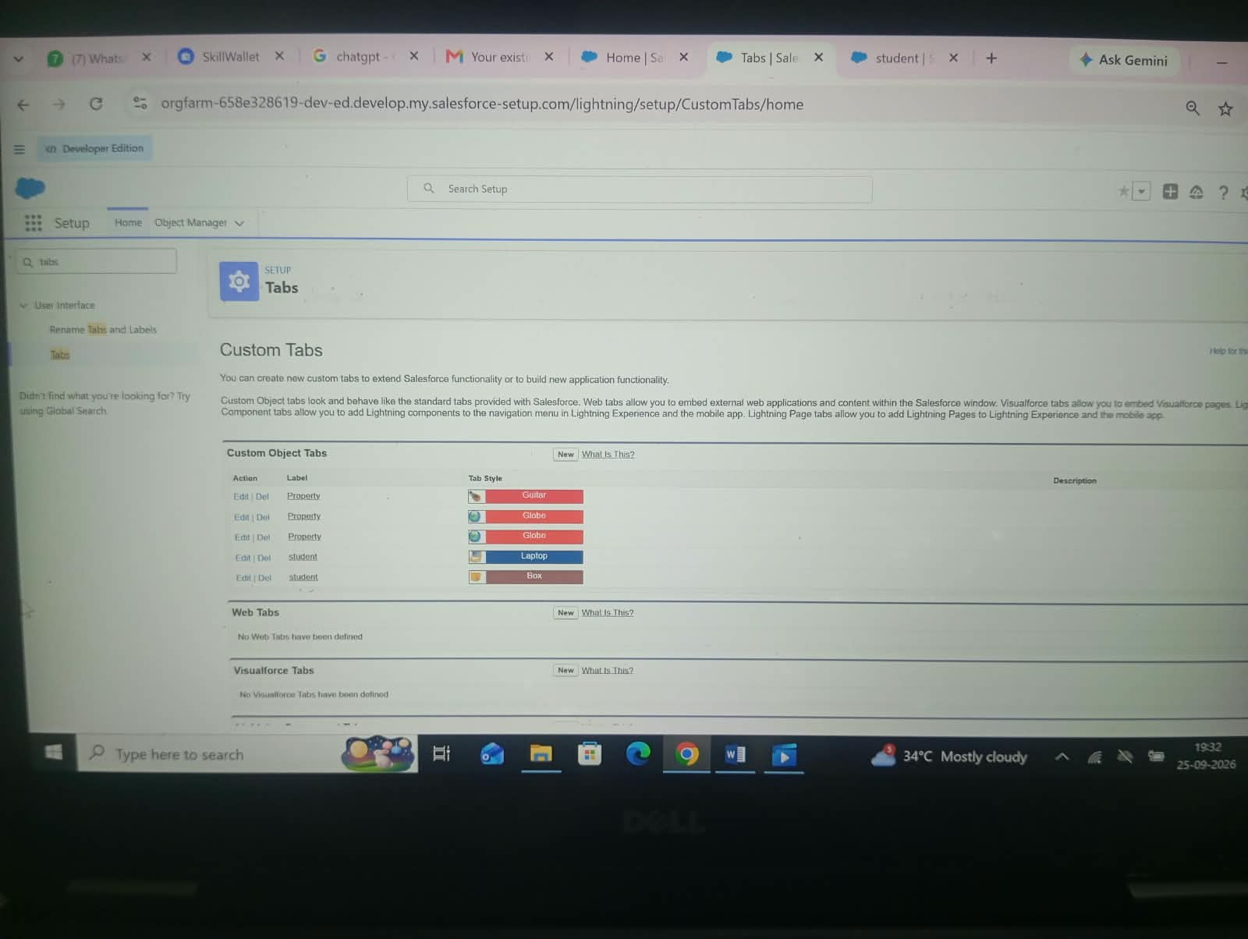
Activity 2: Creating Course Tab:
The purpose of creating the Course Tab is to allow users to view and manage course records quickly.
Go to Setup → Tabs → Custom Object Tabs → New
Select Object: Course
Select Tab Style → Next → Next → Save
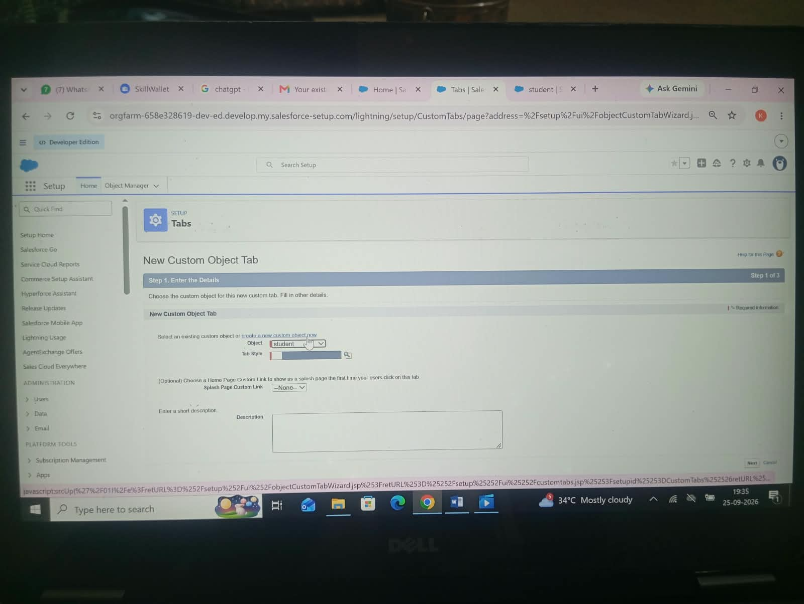
Activity 4: Creating Enrollment Tab:
The purpose of creating the Enrollment Tab is to view and manage student enrollments in courses.
Go to Setup → Tabs → New
Select Object: Enrollment
Tab Style → Next → Next → Save
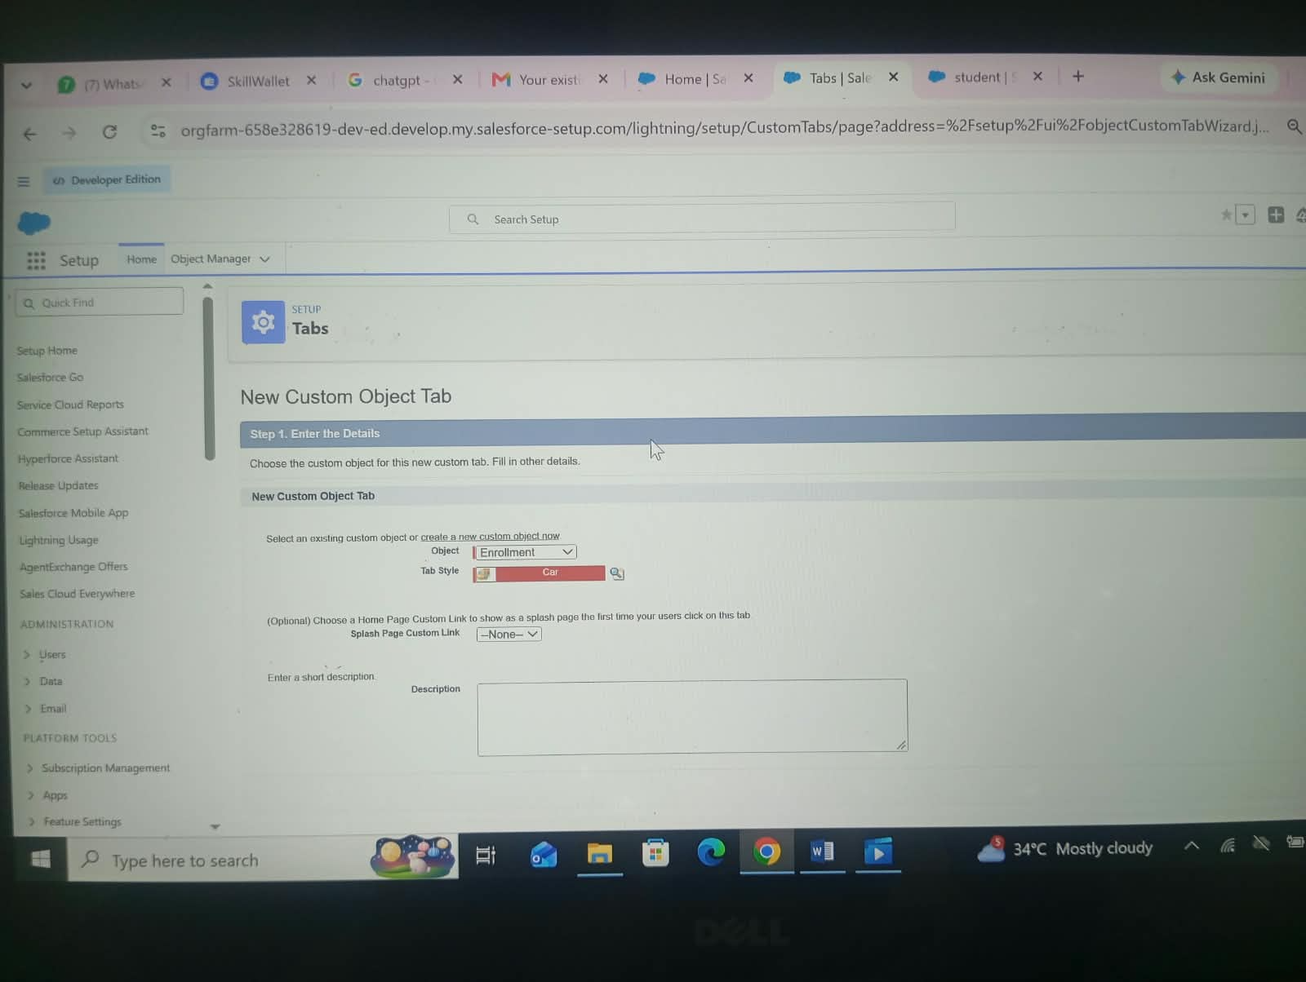
Conclusion
The Student Enrolment & Course Management System (SEMS) project built on Salesforce platform has been successfully complete .Through this project, we learned how to create a complete CRM application from scratch without coding. We created 4 Custom Objects (Student, Course, Instructor, Enrolment), Custom Fields, Tabs, Lightning App (SEMS), Relationships (Lookup & Master-Detail), Flows, and Reports & Dashboards.

PROJECT REPORT
ON
STUDENT ENROLLMENT & COURSE MANAGEMENT SYSTEM (SECMS)
A SALESFORCE PROJECT
Submitted to
KAMBAN COLLEGE OF ARTS AND SCIENCE FOR WOMEN
Department of data Science
Academic Year 2024-2027
PROJECT TEAM DETAILS
Team Lead:
KS - KIRISHA S
kirishas79@gmail.com
Team Members:
KR - KIRUBA R - kirubaraja517@gmail.com
KR - KAVIYA R - rajikaviya867@gmail.com
JG - JEEVITHA G - jeevithagc22@gmail.com
LV - LAVANYA V - gunalavanya61@gmail.com
Guided By:
Department of data Science
Kamban College of Arts and Science for Women

